**Omnicell Dashboard Data Connection**

1. Connect to the SQL Server by selecting Data -> New Data Source -> Microsoft SQL Server. When prompted, enter your facility’s credentials.

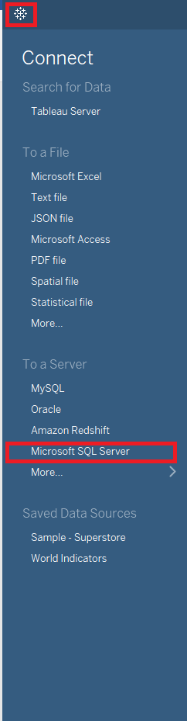

1. On the data page, select “New Custom SQL” located below the list of tables. A t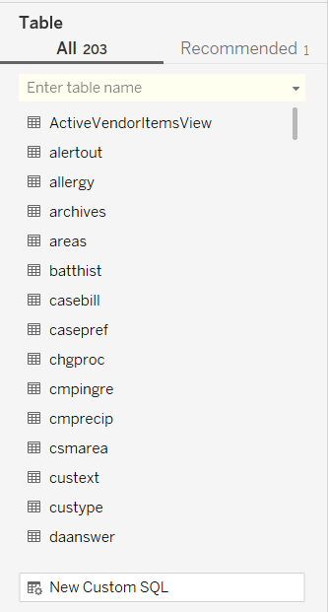extbox will appear where you can copy and paste in the query found in “Omnicell SQL Custom Query.sql”.
2. 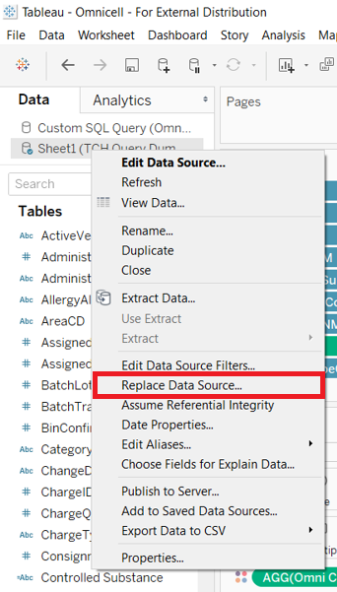Select any worksheet on the bottom ribbon (a dashboard will not work), so that the data pane appears to the left. Replace the data for the source “Sheet1 (TCH Query Dummy)” by right-clicking on the data source and selecting “Replace Data Source…”
3. A pop up will ask for the replacement data source. If it does not appear by default, select “Custom SQL Query” as the new data source.
4. Most all fields will automatically switch to the data for the SQL Query; however, three fields will need to be replaced for the transfer to complete. To replace these fields, right click on the field in the data pane and select “Replace References” then choose the field to replace it with. Below are the three fields and their respective replacements:

* 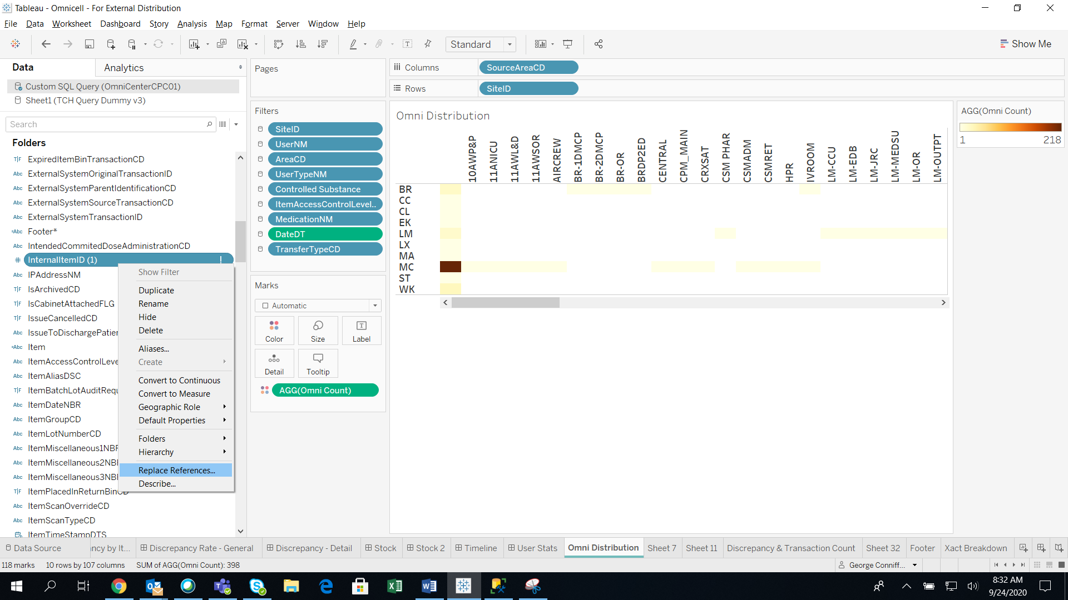InternalItemID (1) => InternalItemID
* TransactionID (1) => TransactionID
* OnHandQtyNBR (1) => OnHandQtyNBR

**Recommendations:**

* When loading the data for the first time, edit the first line of the SQL Query to select a subset of the data “SELECT Top 1000” to validate the data being loaded properly.
* Once the SQL query source is validated, save the data as an extract to improve workbook performance